**Distribution of Orders**

1. **Description of the problem**

Let’s consider a sales company delivering goods for its customers, located in the different places around a city. The company has GPS coordinates representing customers and customers’ orders.

We should answer:

* How many vehicles the company should have in order to supply all its customers for one workday?
* How to divide all destinations among company vehicles taking into account the following factors:
* number of vehicles and their capacities;
* number of customers and their orders.

Example:

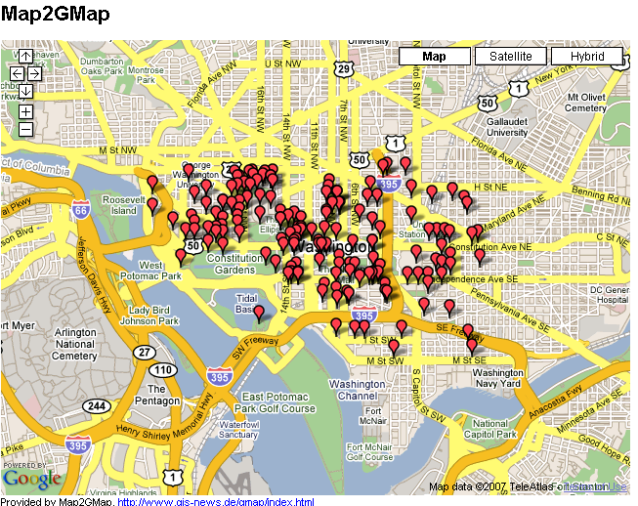

1. **Who is a client?**

Sales/ delivery companies, which would like to provide:

* balanced load of vehicles, based on number of customers and distance among them;
* reducing loss of time.

1. **What data are going to be used?**

Datasets from a delivery company with 1000 customers.

1. **Approaching to solve the problem**

Methods:

* unsupervised learning,
* optimization methods.

1. **What are deliverables?**

* Description of:
* problem with details;
* steps for approaching the problem.
* Python’s code;
* Results analysis including visualizations part.